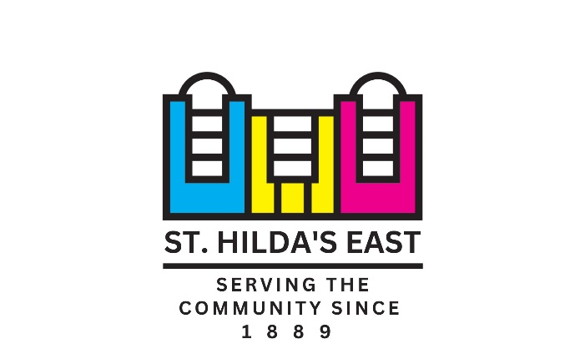
St. Hilda’s East is a local charity which aims to combat the challenges arising from deprivation and social exclusion through the delivery of a wide range of engaging activities which promote wellbeing and social connections. Located in Tower Hamlets, our services include pre-school sensory play, youth programmes, social activities and support for older people, advice, a food co-operative, wellbeing activities for people experiencing mental health issues, and volunteering placements.
Founded in 1889 by alumnae of Cheltenham Ladies’ College, we now work from two sites – our large, friendly community centre located in Shoreditch and an Elders Day Centre for the Bangladeshi and other communities in Shadwell. This year, we are commemorating our 135th anniversary for which we have launched a fundraising campaign.
See www.sthildas.org.uk for more information.

JOB DESCRIPTION
JOB TITLE: Receptionist (Full time – job share will be considered)
REPORTS TO: Head of Operations
WORKPLACE: Based at 18 Club Row
SALARY: £27,008
HOURS: 37.5 hours per week – Monday to Friday either starting at 8.45am or finishing at 6pm with a half-hour unpaid lunch break. (Full time – job share will be considered)

ANNUAL LEAVE: 25 days plus bank holidays

Job Purpose:
Based at the main entrance of the St Hilda’s East Community Centre in Shoreditch, the Receptionist primarily provides a friendly welcome to all visitors, staff and tenants in person and over the telephone. ﻿The role of Receptionist is varied and supports multiple aspects of the centre’s operation.

Responsibilities:
- Acts as an ambassador for St Hilda’s East by providing a friendly and helpful welcome to all visitors, staff and tenants.

- Controls access to the building by ensuring all visitors are signed in / out and directed to the appropriate area.

- Acts as the information hub for the Centre and its services - including booking appointments and signposting.

- Answers phones in a friendly manner and directs incoming calls accordingly.

- Takes enquiries and assists with securing bookings for lettings/events in accordance with procedures.

- Maintains an up-to-date Reception Manual, adheres to the processes within and makes suggestions for improvements.

- Provides general administrative support to colleagues.

- Monitors and replies to the general incoming SHE emails.

- Sets up rooms for activities and meetings.

- Responsible for receiving incoming mail and packages.

- With support from the Head of Operations, schedules day-to-day, one-off, and regulatory maintenance and repair of our premises and equipment.

- Undertakes general office tasks including, scanning, photocopying, data entry and filing.

- Undertakes regular, routine checks to ensure that all communal areas of the building are safe, clean, and tidy.

- Undertakes light cleaning duties, when required.

- Assisting with weekly Fire Alarm tests and routine risk assessments.

- Opens up the building on office workdays.

General Responsibilities
- Participate positively in regular supervision, appraisal, and training and networking events.

- Ensure that all SHE policies and procedures are adhered to, particularly those relating to safeguarding, health and safety, equal opportunities, and the environment.

- Undertake any other duties that may be required which are commensurate with the role.

PERSON SPECIFICATION

Essential skills

- A real people person - super-friendly and welcoming to people of all backgrounds.

- An understanding of the differing needs of diverse communities with a commitment to implementing good practice around equal opportunities.

- Proficiency in speaking Sylheti/Bengali.

- A strong customer-focused background, with the ability to support members of the public who may be showings signs of distress.

- A quick learner with the ability to work on your own initiative.

- The ability to manage a busy workload and to multi-task with the ability to prioritise tasks in an organised and unflappable manner.

- Has proficiency in Microsoft Office and has good administrative skills.

- A good team player, able to effectively coordinate with colleagues.

Desirable Skills

- Has a good understanding of the needs of the local community and knowledge of local services.

How to Apply

Please apply by submitting your CV and a cover letter. The cover letter should be no more than 2 pages long and should explain point by point how you meet each of the Essential Criteria on the Person Specification. Don’t forget to provide examples to evidence your experience and abilities.

For further information about the role, please contact Daniel on 020 7739 8066.
Your application should be submitted to hr@sthildas.org.uk by 23.59 on Sunday 13th April 2025.
Interviews will take place during week commencing 21st April 2025.

